PROJECT REPORT

**Project Name**: Personal Assistance for Seniors Who Are Self-Reliant

**Team ID:** PNT2022TMID19437

**Team:** Vaijayanth S– Team leader

Sabari Mukundth

Santhosh T

Sanjay R

## INTRODUCTION

* 1. Project Overview
  2. Purpose

1. **LITERATURE SURVEY**
   1. Existing problem
   2. References
   3. Problem Statement Definition
2. **IDEATION & PROPOSED SOLUTION**
   1. Empathy Map Canvas
   2. Ideation & Brainstorming
   3. Proposed Solution
   4. Problem Solution fit
3. **REQUIREMENT ANALYSIS**
   1. Functional requirement
4. **PROJECT DESIGN**
   1. Data Flow Diagrams
   2. Solution & Technical Architecture
5. **PROJECT PLANNING & SCHEDULING**
   1. Sprint Planning, Schedule & Estimation
6. **CODING & SOLUTIONING (Explain the features added in the project along with code)**
   1. Feature
7. **TESTING**
   1. Test Cases
   2. User Acceptance Testing
8. **RESULTS**
   1. Performance Metrics **10.ADVANTAGES & DISADVANTAGES 11.CONCLUSION**

## FUTURE SCOPE

1. **APPENDIX**

Source Code

GitHub & Project Demo Link

* 1. **Introduction**

### Project Overview

* + - An app is built for the user (caretaker) which enables him to set the desired time and medicine. These details will be stored in the IBM Cloudant DB.
    - If the medicine time arrives the web application will send the medicine name to the IoT Device through the IBM IoT platform.
    - The device will receive the medicine name and notify the user with voice commands.

### Purpose

* + - Sometimes elderly people forget to take their medicine at the correct time.
    - They also forget which medicine He / She should take at that particular time.
    - And it is difficult for doctors/caretakers to monitor the patients around the clock. To avoid this problem, this medicine reminder system is developed.

# Literature survey

### Existing problem

Elderly people let slip the medications at the correct time and the existing solutions for this problem is setting reminders or using pill boxes, calendars, Personal Assistance. Though the solutions give reminders, the voice commands or assistance given by this system is more efficient.

### References

* + 1. Visual Health Reminder: A Reminder for Medication Intake and Measuring Blood Pressure to Support Elderly People ; René Baranyi; Sascha Rainer; Stefan Schlossarek; Nadja Lederer; Thomas Grechenig
    2. Cloud Computing based Medical Assistance & Pill Reminder ; A. Chinnasamy; Ram Prasad J; Syed Rafeeq Ahmed; Akash S

### Problem statement definition

Skipping medicines can be serious for some medical health conditions; Sometimes elderly people forget to take their medicine at the correct time.They also forget which medicine one should take at that particular time. And it is difficult for doctors/caretakers to monitor the patients around the clock.

# Ideation and proposed solution

### Empathy Map Canvas

* 1. **Ideation and Brainstorming**

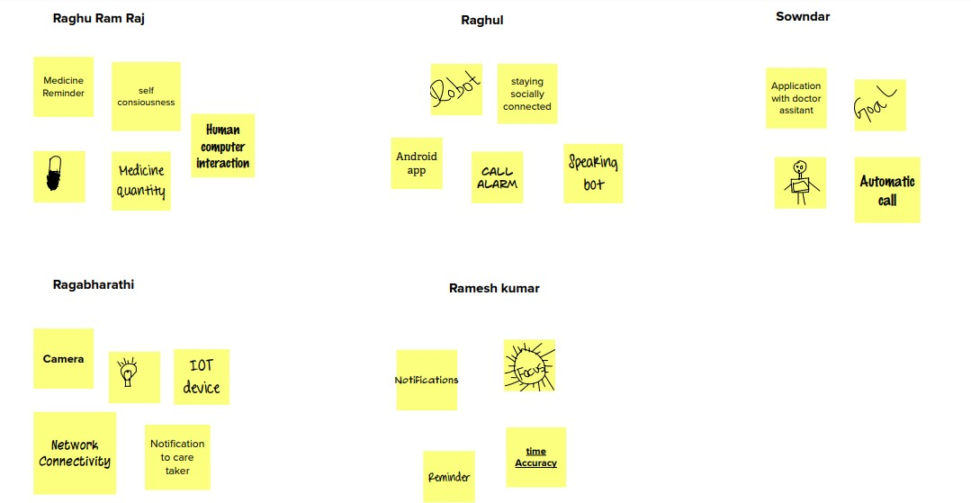

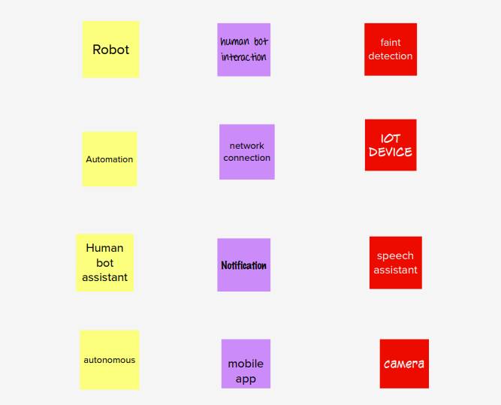

* 1. **Proposed solution**

|  |  |  |
| --- | --- | --- |
| **S.No.** | **Parameter** | **Description** |
| 1. | Problem Statement (Problem | Sometimes elderly people forget to take |
| to be solved) | their medicine at the correct time. They |
|  | also forget which medicine should be taken |
|  | at that particular time. And it is difficult |
|  | for doctors/caretakers to monitor the |
|  | patients around the clock. |
| 2. | Idea / Solution description | * A medicine reminder system is |
| developed. An app is built for the |
| user (caretaker) which enables him |
| to set the desired time and |
| medicine. |
| * These details will be stored in the |
| IBM Cloudant DB. If the medicine |
| time arrives the web application |
| will send the medicine name to the |
| IoT Device through the IBM IoT |
| platform. |

|  |  |  |
| --- | --- | --- |
|  |  | * The device will receive the |
| medicine name and notify the user |
| with voice commands. |
| 3. | Novelty / Uniqueness | * Keeping track of the medicines |
| taken by the user at each time |
| interval. |
| * Information is stored in the secured |
| IBM cloud. |
| 4. | Social Impact / Customer | The reminder system enables the user to |
| Satisfaction | take tablets at regular intervals prescribed |
|  | by the physicians. |
| 5. | Business Model (Revenue | **Direct Mode:** We gain revenue from |
| Model) | selling the medical reminder system to |
|  | hospitals, medical health centres and even |
|  | in old age homes. |
|  | **Indirect Mode:** We gain profit by having |
|  | partnership with pharmaceutical |
|  | companies. |
| 6. | Scalability of the Solution | The medical alert system can be used in |
| hospitals, medical health centres and even |
| in old age homes for dispensing medicines. |

* 1. **Problem Solution fit**

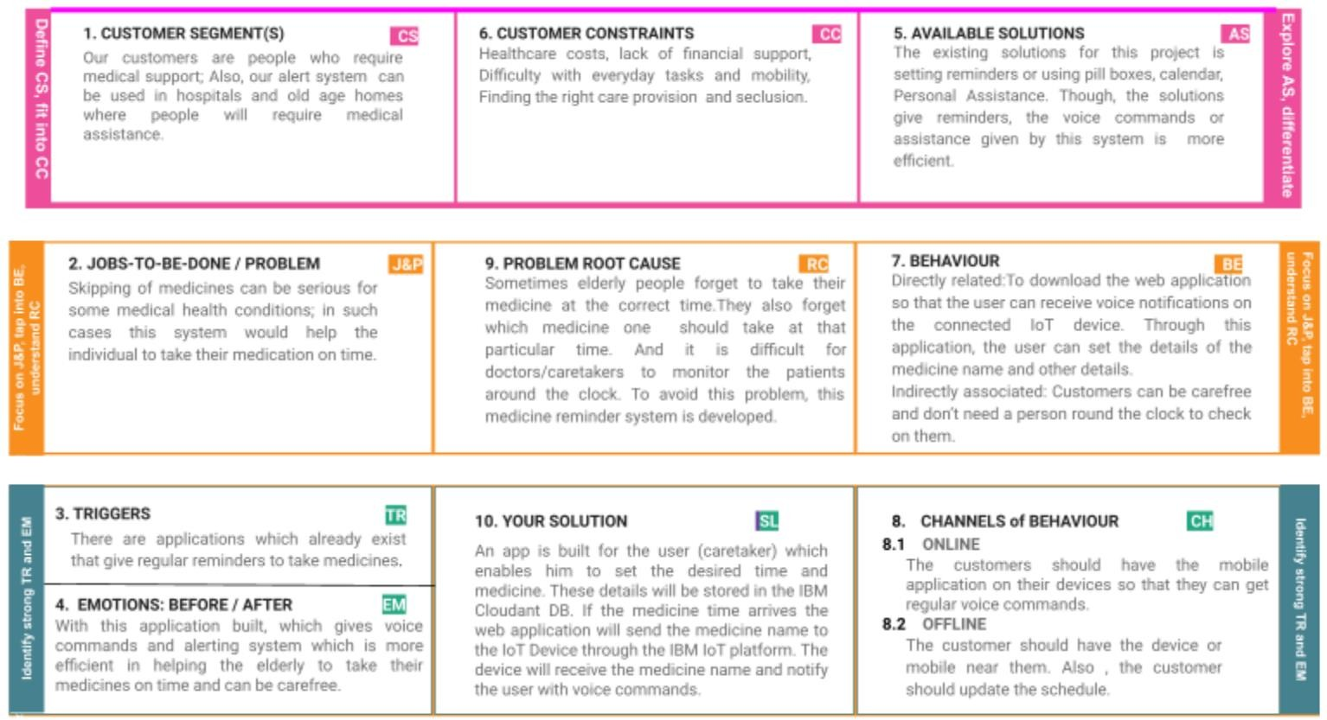

* 1. **Requirement analysis**
  2. **Functional Requirements:**

|  |  |  |
| --- | --- | --- |
| **FR** | **Functional** | **Sub Requirement (Story / Sub-Task)** |
| **No.** | **Requirement** |
|  | **(Epic)** |
| FR-1 | User Registration | Registration through Form Registration |
| through Gmail |
| FR-2 | User Confirmation | Confirmation via Email |
| Confirmation via OTP |
| FR-3 | Access Cloud services | Accessing the cloud service with correct |
| credentials. Storing the details in the cloud |
| database. |
| FR-4 | IOT configuration | Fine Tuning the IOT device based |
| Cloud DB access via device. |
| Manage the data request and |
| response effectively |

* 1. **Non-functional Requirements:**

|  |  |  |
| --- | --- | --- |
| **FR** | **Non-Functional** | **Description** |
| **No.** | **Requirement** |
| NFR- | **Usability** | App can be used by anyone who has |
| 1 | knowledge about applications and |
|  | computers. |
| NFR- | **Security** | For security, TFA is enabled and |
| 2 | biometrics arealso added for user |
|  | safety. |
| NFR- | **Reliability** | Highly reliable since, It usestrusted and |
| 3 | authentic cloud services like IBM |

|  |  |  |
| --- | --- | --- |
| NFR- | **Performance** | Performance is better compared to other |
| 4 | marketproducts. |
| NFR- | **Availability** | Available on mobile app. |
| 5 |
| NFR- | **Scalability** | Using Cloud services, makes the |
| 6 | scalability higher the using |
|  | traditional locally stored database. |

* 1. **Project Design**
  2. **Data Flow Diagrams**

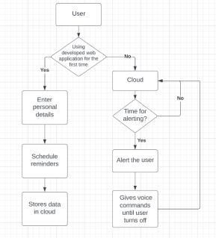

* 1. **Technical architecture**

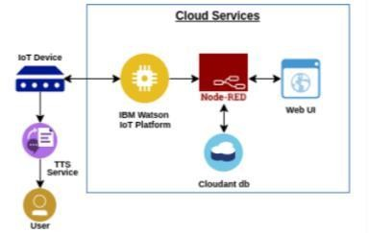

* 1. **User Stories**

|  |  |  |  |  |  |  |
| --- | --- | --- | --- | --- | --- | --- |
| **User** | **Functional** | **User** | **User Story / Task** | **Acceptanc** | **Priorit** | **Release** |
| **Type** | **Requireme** | **Story** | **e criteria** | **y** |
|  | **nt (Epic)** | **Num** |  |  |
|  |  | **ber** |  |  |
| Customer | Registratio | USN- | As a user, I can register | I can | High | Sprint-1 |
| (Mobile | n | 1 | for the application by | access my |
| user) |  |  | entering my email or | account / |
|  |  |  | mobile number, | dashboard |
|  |  |  | password, and |  |
|  |  |  | confirming my |  |
|  |  |  | password. |  |
|  |  | USN- | As a user, I will receive | I can | High | Sprint-1 |
| 2 | confirmation email once | receive |
|  | I have registered for the | confirmati |
|  | application | on email |
|  |  | & click |
|  |  | confirm |
|  |  | USN- | As a user, I can register |  | Mediu | Sprint-1 |
| 3 | for the application | m |
|  | through Gmail |  |
|  | Login | USN- | As a user, I can log into | I can | High | Sprint-1 |
| 4 | the application by | access my |
|  | entering email or mobile | account / |
|  | number & password | dashboard |

|  |  |  |  |  |  |  |
| --- | --- | --- | --- | --- | --- | --- |
| **User** | **Functional** | **User** | **User Story / Task** | **Acceptanc** | **Priorit** | **Release** |
| **Type** | **Requireme** | **Story** | **e criteria** | **y** |
|  | **nt (Epic)** | **Num** |  |  |
|  |  | **ber** |  |  |
|  | Dashboard | USN- | As a user, I can update |  | High | Sprint-2 |
| 5 | my reminders and |
|  | medicines wherever |
|  | required |
|  |  | USN- | As a user, I can check the |  | Mediu | Sprint-2 |
| 6 | application whether the | m |
|  | medicine dosage is |  |
|  | completed. |  |
| Customer |  | USN- | For any troubleshooting, |  | Low |  |
| Care | 7 | the user can send a mail |
| Executiv |  | to the technical team. |
| e |  |  |
| Administ |  | USN- | Ensures smooth |  | Mediu | Sprint-3 |
| rator | 8 | functioning and data | m |
|  |  | warehousing strategies |  |

* 1. **Project Planning and Scheduling**

**6.1. Sprint Planning and Estimation**

|  |  |  |  |  |  |  |
| --- | --- | --- | --- | --- | --- | --- |
| **Sprint** | **Functional Requiremen**  **ts(Epic)** | **User story**  **Number** | **User Story / Task** | **Story points** | **Priority** | **Team Members** |
| Sprint- 1 | Registration | USN-1 | As a user, I can register for the application by entering my email or mobile number, password, and confirming  my password | 2 | High | Raghu Ram Raj N |
| Sprint- 1 |  | USN-2 | As a user, I will receive confirmation email once I have registered for the  application | 1 | High | Rameshkumar V |
| Sprint- 1 |  | USN-3 | As a user, I can register | 2 | Medium | Rahul A |
| Sprint-1 |  | USN-4 | As a user, I can log into the application by entering email or mobile number &  password | 2 | High | Ragabharthi A |
| Sprint- 2 | Login | USN-5 | As a user, I can update my  remainders and medicines whenever required | 1 | high | Sowndar K |
| Sprint-2 | Dashboard | USN-6 | As a user, I can check the application whether the medicine dosage is  completed | 1 | Medium | Raghu Ram Raj N |
|  |  | USN -7 | For any troubleshooting, the user can send a mail to the technical team | 1 | Low | Rahul A |
| Sprint-3 |  | USN-8 | Ensures smooth functioning  and data warehousing strategies | 1 | Medium | Rameshkumar V |

**6.2 Sprint Delivery Scheduling**

|  |  |  |  |  |
| --- | --- | --- | --- | --- |
| **Sprint** | **Total story points** | **Duration sprint start date end date(planned)** | **Story points completed (as on planned end date)** | **Sprint Release date(actual)** |
| Sprint-1 | 20 | 10 days (24 Oct 2022 - 03  Nov 2022) | 20 | 03 Nov 2022 |
| Sprint-2 | 20 | 5 days (04 Nov 2022 - 09  Nov 2022) | 20 | 09 Nov 2022 |
| Sprint-3 | 20 | 5 days (10 Nov 2022 - 15  Nov 2022) | 20 | 15 Nov 2022 |
| Sprint-4 | 20 | 2 days (16 Nov 2022 - 17  Nov 2022) | 20 | 17 Nov 2022 |

* 1. **Coding and Solutioning**

### Feature 1

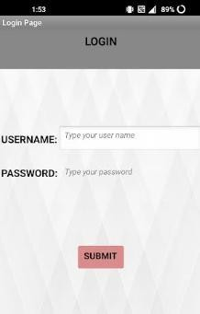The mobile application developed has a feature of individual login by different users.

### Feature 2

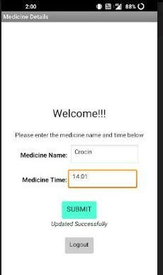The mobile application also has the feature of uploading medicine names in the cloud.

### 7.3. Feature 3

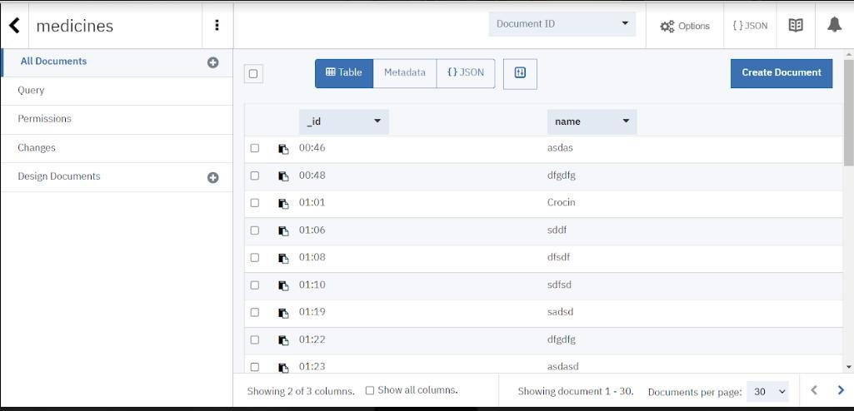The project includes a cloud database system.

### Test cases

* 1. **Testing**

|  |  |  |  |  |  |
| --- | --- | --- | --- | --- | --- |
| **Test case** | **Precondition** | **Test steps** | | **Test data** | **Expected** |
| **result** |
| Verify login with | User should | 1. | Launch URL | Username: | Users should |
| valid credentials | have a network | 2. | Enter valid username. | Raghu | be able to login |
|  | connection | 3. | Enter valid password. | Password: | successfully. |
|  |  | 4. | Click on the “Login” | 12345 |  |
|  |  | button. | |  |  |
| Verify login with | User should | 1. | Launch URL | Username: | Users should |
| invalid credentials | have a network | 2. | Enter valid username. | Raghu | not be able to |
|  | connection | 3. | Enter invalid password. | Password: | login. |
|  |  | 4. | Click on the “Login” | Navya123 |  |
|  |  | button. | |  |  |
| Update the | User should | 1. | Enter valid medicine | Medicine | Users should |
| medicine name | have a network | name. | | Name: | be able to |
| with the time. | connection | 2. | Enter the time when the | Cetirizine | update it |
|  |  | medicine has to be | | Medicine | successfully. |
|  |  | consumed. | | Time: |  |
|  |  | 3. | Click on the “Submit” | 20.00 |  |
|  |  | button. | |  |  |

* 1. **User acceptance**

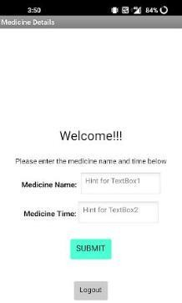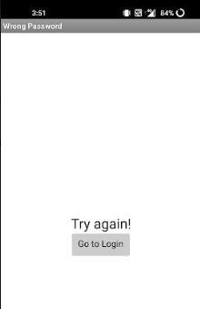**testing Login page testing Incorrect login attempt**

### Medicine page testing

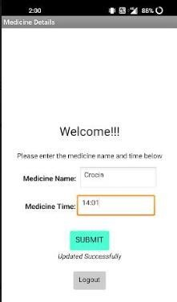

* 1. **Performance Metrics**
  2. **Results**

|  |  |  |
| --- | --- | --- |
| **S. NO** | **Parameter** | **Performance** |
| 1. | Response Time | 0.2s (Average of 10 trials) |
| 2. | Workload | 500 users ( Calculated based on Cloud Space) |
| 3. | Revenue | Individual users and pharmaceutical industries. |
| 4. | Efficiency | Simple and straightforward workflow, which makes the |
| process efficient. |
| 5. | Down Time | Almost no down time due to IBM Cloud enabled |
| solution. |

* 1. **Advantages and Disadvantages**

**Advantages**

* + - Help the elderly people to take their medicine at the correct time.
    - Avoid personal assistants or caretakers needed for medically sick people.
    - Cost efficient.
    - Can store multiple data and many notifications can be generated.
    - Since it includes voice assistance, even blind people can use our device.

### Disadvantages

* + - Makes people lethargic and makes them dependent always on others.
    - Requires a stable internet connection.

# Conclusion

The project offers the elderly or medically sick people a personal assistant which reminds them of the medicines to be consumed at the particular time. Skipping tablets may lead to serious problems if the person has a severe illness and this can be avoided. Since the cloud is integrated with the mobile application, numerous data can be fed into the database and notifications can be generated. The mobile application developed is highly customisable by the user and easy to use.

# Future Scope

The project can be further developed by bringing into the feature of informing the medicine name during the notification. The voice assistance which is given can be customized by adding the user's voice or the caretaker’s voice. Further the mobile application can update medicines by taking voice commands as an input from the user.

# Appendix

### Source Code:

#include <WiFi.h>//library for wifi

#include <PubSubClient.h>//library for MQtt #include "SoundData.h"

#include "XT_DAC_Audio.h"

XT_Wav_Class Sound("voice_command.wav"); XT_DAC_Audio_Class DacAudio(2,0); uint32_t DemoCounter=0;

void callback(char* subscribetopic, byte* payload, unsigned int payloadLength);

//-------credentials of IBM Accounts------

#define ORG "ut4tn5"//IBM ORGANITION ID

#define DEVICE_TYPE "Arduino"//Device type mentioned in ibm watson IOT Platform #define DEVICE_ID "nitish123"//Device ID mentioned in ibm watson IOT Platform #define TOKEN "123456789" //Token

String data3; float h, t;

//-------- Customise the above values --------

char server[] = ORG ".messaging.internetofthings.ibmcloud.com";// Server Name

char publishTopic[] = "iot-2/evt/Data/fmt/json";// topic name and type of event perform and format in which data to be send

char subscribetopic[] = "iot-2/cmd/test/fmt/String";// cmd REPRESENT command type AND COMMAND IS TEST OF FORMAT STRING

char authMethod[] = "use-token-auth";// authentication method char token[] = TOKEN;

char clientId[] = "d:" ORG ":" DEVICE_TYPE ":" DEVICE_ID;//client id

//

WiFiClient wifiClient; // creating the instance for wificlient

PubSubClient client(server, 1883, callback ,wifiClient); //calling the predefined client id by passing parameter like server id,portand wificredential void setup()// configureing the ESP32

{

Serial.begin(115200);

delay(10); Serial.println(); wificonnect(); mqttconnect();

}

void loop()// Recursive Function

{

delay(1000);

if (!client.loop()) { mqttconnect();

}

}

/*.....................................retrieving to Cloud. */

void mqttconnect() {

if (!client.connected()) { Serial.print("Reconnecting client to "); Serial.println(server);

while (!!!client.connect(clientId, authMethod, token)) {

Serial.print("."); delay(500);

}

initManagedDevice(); Serial.println();

}

}

void wificonnect() //function defination for wificonnect

{

Serial.println(); Serial.print("Connecting to ");

WiFi.begin("Wokwi-GUEST", "", 6);//passing the wifi credentials to establish the connection

while (WiFi.status() != WL_CONNECTED) { delay(500);

Serial.print(".");

}

Serial.println(""); Serial.println("WiFi connected"); Serial.println("IP address: "); Serial.println(WiFi.localIP());

}

void initManagedDevice() {

if (client.subscribe(subscribetopic)) { Serial.println((subscribetopic)); Serial.println("subscribe to cmd OK");

} else {

Serial.println("subscribe to cmd FAILED");

}

}

void callback(char* subscribetopic, byte* payload, unsigned int payloadLength)

{

Serial.print("callback invoked for topic: "); Serial.println(subscribetopic);

for (int i = 0; i < payloadLength; i++) {

//Serial.print((char)payload[i]); data3 += (char)payload[i];

}

Serial.println("data: "+ data3); if(data3=="announce")

{

Serial.println(data3); for(int i=0;i<5;i++){ DacAudio.FillBuffer(); if(Sound.Playing==false)

DacAudio.Play(&Sound); Serial.println(DemoCounter++);

}

}

else

{

pass;

}

data3="";

}

**Github link**: https://github.com/IBM-EPBL/IBM-Project-38820-1660385726